16-281 Lab 5 - Path Planning

Lab TA’s: Omar Aldhaher, Varun Sureka, Kenji Tella

Lab 5 Feedback Form

Goal

Given a start pose and end position, plan and execute a path through a known map of obstacles to reach the goal.

Overview

Specifications:
- The robot can be no larger than 1 ft x 1ft x 1ft, but a smaller robot may be better.
- Teams can decide the reference point on the robot. We will be comparing this point with the desired end point when calculating the L2 error. The reference point must be consistent during the demo.
- The start position (x1, y1) and end position (x2, y2) will be at least 5 inches away from all obstacles, including the wall.
- The robot will be initially oriented in a random cardinal direction.
- The map’s origin is at the bottom left corner of the course.
- The border is 6 feet by 4 feet 6 inches. (72” x 54”)
- All positions are in inches and within ⅛”.

Easy course specifications:
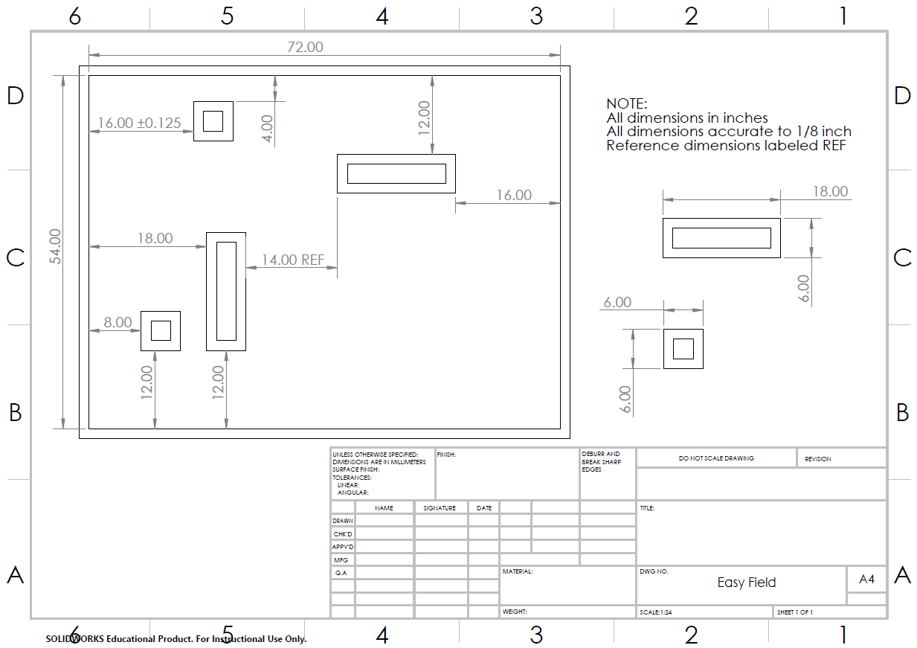

Hard course specifications:
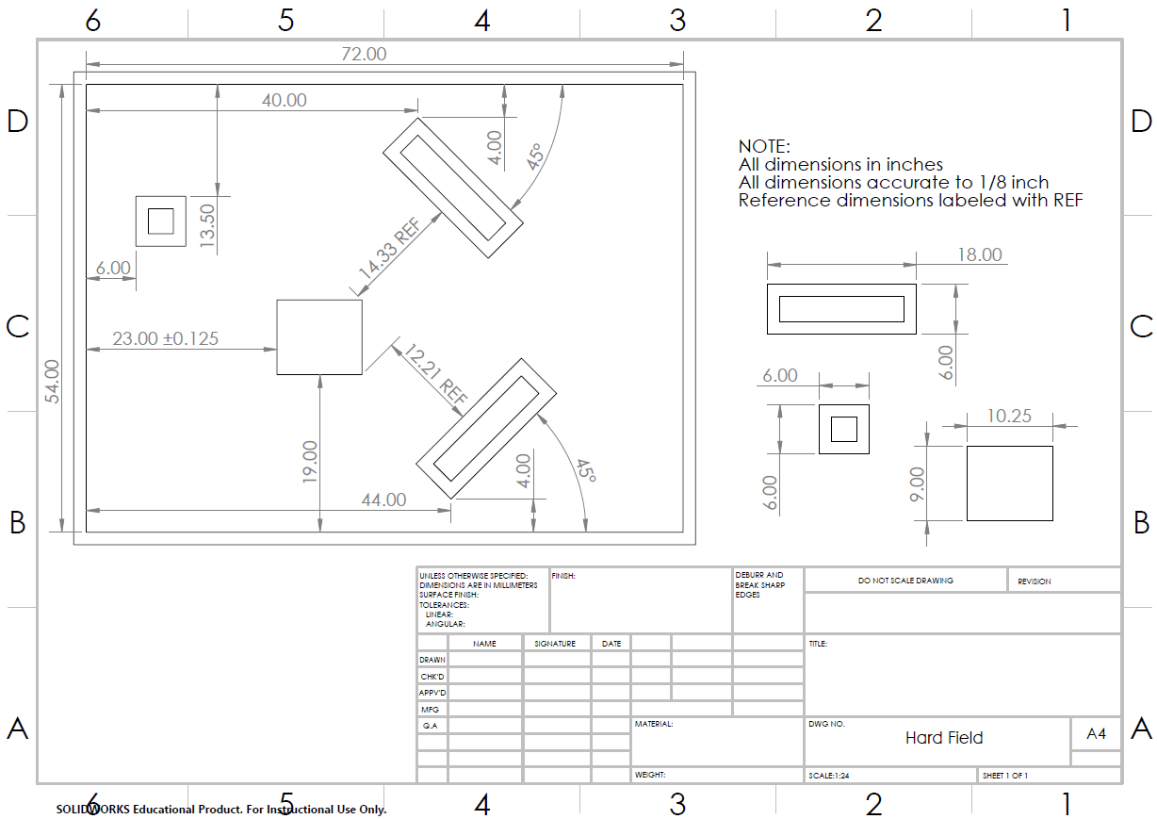

Tasks
- Download and unzip lab5StarterCode that contains:
  - construct_map.py (to help you port maps into your code)
  - Pseudo code for A*
  - Pseudo code for wavefront planner
  - Pseudo code for roadmap path planning strategy
- Prepare your odometry as necessary so that it can interface with the rest of the code you will write.
- Think about your map representation (grid, voronoi, visibility, etc). Which one will you choose? How will you represent it?
  - Remember to incorporate your c-space into your map representation.
  - We provide easy map and hard map text files in the starter code and you can refer to them and use them in your code; however, you can certainly define your own map using your own method. The txt files we provided are only for references.
  - For better code modularity, we recommend creating a separate file for map representation helper functions.
- Write your path planning algorithm. This does not need to be done in the same file as your motor commands.
  - You can write this in any language you choose.
  - You cannot use any built-in graph search functions or packages that trivialize this (ask on Piazza).
- Choose any algorithm you want! (ask: optimal with respect to what?)
  - Bug 1 / Bug 2
  - Wavefront
  - Potential function
  - Djikstra/A*
  - Anything else!
Note: During demos, you will need to show the TA the path before your robot moves. This can be done automatically through your code (using visualization tools) or by hand (ex. Draw a path through waypoints on an existing image of the map with waypoints).
- Write your path following code. Convert the path above to motor commands. Here are some options to consider.
  - Blind point-and-drive (Is this a good idea?)
  - Some combination of PID on heading error and/or lateral error from the path
  - Pure pursuit
  - Anything else!
Choose one that works best for your team.
- Use the sign up sheet posted on Piazza to sign up for a demo slot.

Demo Procedures
Sign up sheet for demo slots will be posted on piazza.
- Choose a reference point on your robot (all measurements will be made with respect to that point).
- You will be given a start position (x1, y1) and end position (x2, y2). They will be at least 5 in from all obstacles (including the walls). These coordinates will be with respect to a bottom-left origin.
  - E.g. “You starting position is (40, 32) and goal is (16, 8)”
- Your robot will initially be oriented in one of the four cardinal directions. (Picked randomly during demo!)
- Run your path planning algorithm to determine the path to be taken by the robot. You must show this path to the TA before the robot moves.
  - This does NOT have to be done on the BrickPi. You may use Python, MATLAB or any other tools to generate your trajectory.
- Your robot will navigate from the given starting position to the given ending position within specified time limits.
You will be graded on the L2 error between the goal position and the reference point on your robot, and the time taken to get there.

Rules & Regulations
- The obstacles are assumed to be infinitely tall
  - No part of your robot can hover over the top of the obstacles regardless of how tall they are in the real world.
- Your demo stops when your robot stops
  - Your L2 error will be calculated from the position of your robot at the time the trial was stopped.
  - You may not prematurely stop your robot while it is completing its path
- We will give you start/end points using the axes convention outlined earlier.
  - If you are using a different convention, it is your responsibility to convert what we give you to what you actually need.
- You are NOT allowed to use any sensors.
- There is a required video demo. The video demo will provide you with a maximum of 50%, if your in-person demo grade is below 50%.
- You are NOT allowed to use library functions to plan any part of your path (data structures like priority queues and such are allowed).
Requirement: Displaying your path

- You must show TAs the intended path/trajectory before your robot moves
  - Your path must be easily understandable for TAs during the demo.
Ex: If you use waypoints, you can show an image of a map with waypoints marked on it.
    - Showing the TAs a list of points that the robot will follow is a valid way of showing an intended path
  - You could generate a map with the clearly identifiable path displayed on it using tools like Matlab or Python
    - If you choose Matlab in conjunction with Python, please be sure to practice interfacing between Matlab and Python by demo day (given very limited demo time)
- Time taken to calculate the path will be part of your 7 minute demo slot.
  - You will need to calculate and show the path for each of the three trials.
Individual Q & A
- At the end of your team’s demo, we will ask each member of your group one question (3 total questions) that can be related to any of the following:
  - General path planning algorithms
  - Your team’s implementation for the lab
  - The trade-offs your team made when implementing your algorithm
  - Real-world path planning
- MAKE SURE you fully understand every aspect of your team’s implementation before the demo.
- You will NOT be allowed to consult with your teammates when we ask you a question.

Grading
The rubric is located here. You have 3 TRIALS in total, but both have to be on the same course.
Attempts on the hard course get 5 free points, and this CAN get you extra credit

Tips / Common Issues
- Start early!
- Consider what constitutes the optimal path
  - “Optimal with respect to what?”
  - Speed vs. Safety vs. Accuracy
- Take time to tune your dead-reckoning properly
- Choose your algorithm carefully
  - Ease of implementation
  - Quality of solution
  - Reliability
- Practice the demo procedure before your demo!
  - Ensure that the path you calculated can be easily ported into your path following code
- Hitting an obstacle will severely hurt your chances of successfully completing a path.
  - Designing your path planner to optimize for safety is recommended
- Your code from Lab 3 (Odometry) with PID incorporated into it will be useful for this lab.
- This lab will get more complicated when path planning and path following come together. To make your code more organized, we recommend to create helper function files and import them into your main code.
- More issues may occur during testing and tuning. Please ask on piazza if you encounter great difficulties. More office hours for lab TAs will be posted in calender.

